## Server groups

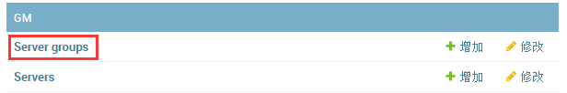

Server groups is used for define announcement file path(it’is same as the game update package file path)

The announcement:

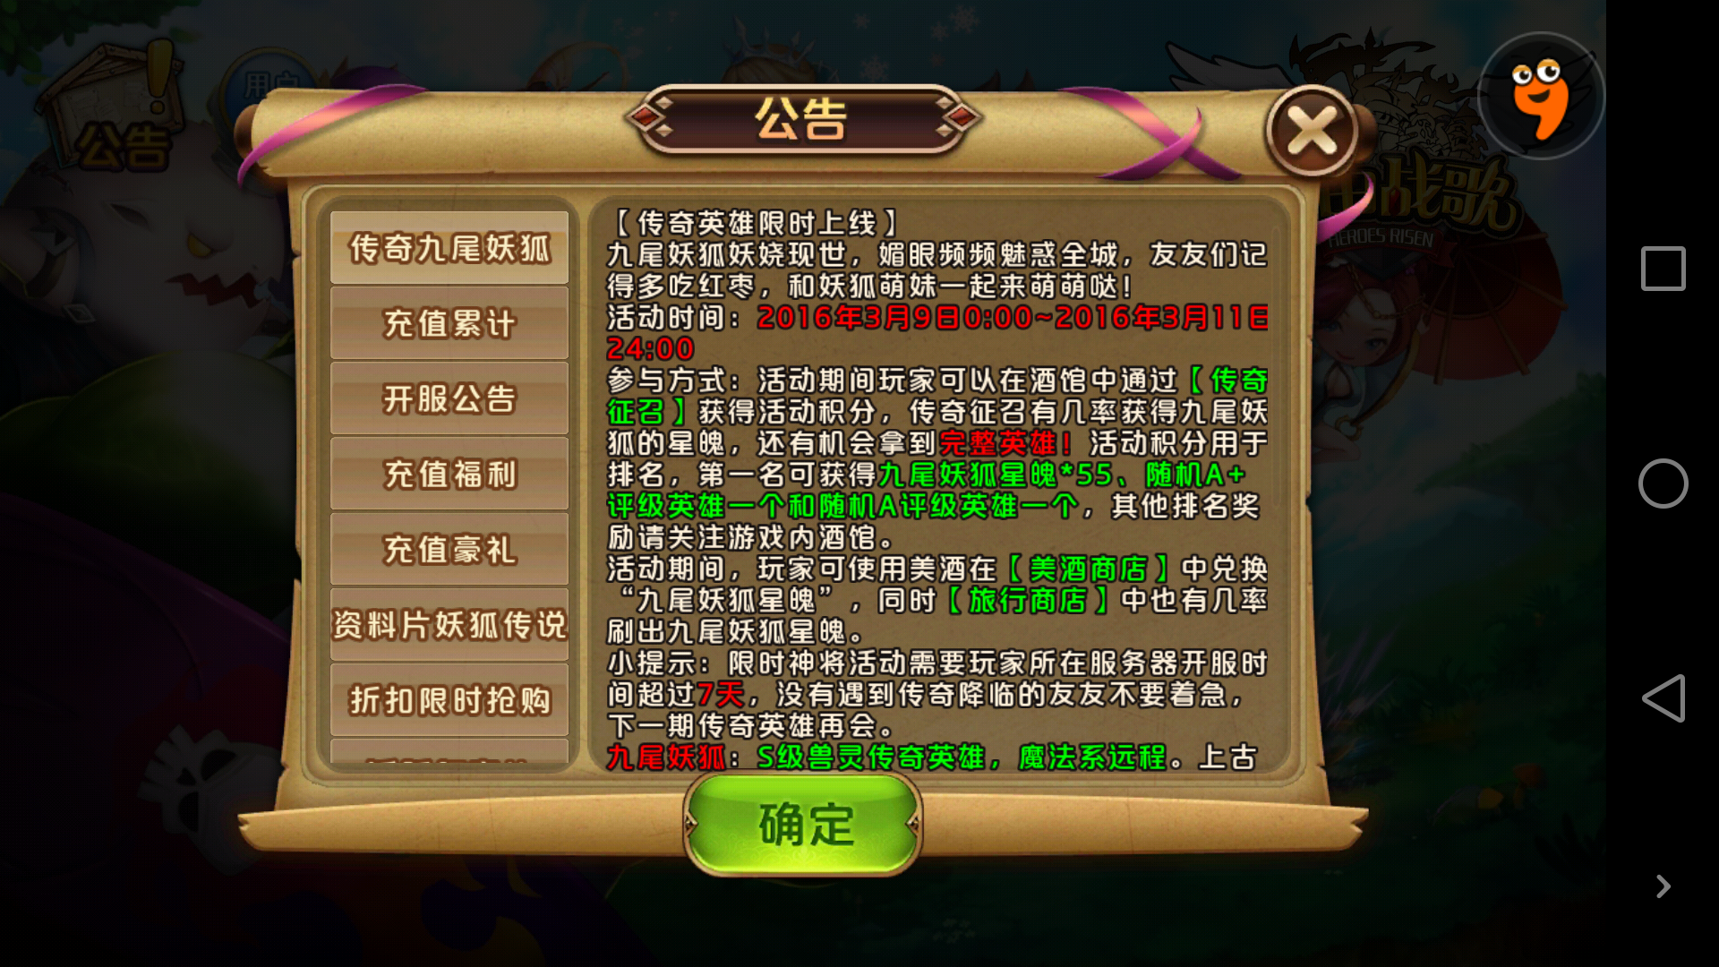

1. to enter the groups server page，the upper right corner of the "**增加 server group**", click on this button
2. fill in the required additional group server information

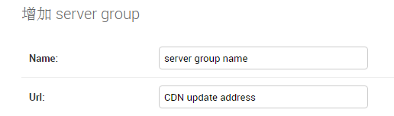

1. fill in the bottom right corner“保存”



1. To enter the "user" of the "authentication and authorization" page
2. right upper corner "to increase the user", fill in the user name, password, confirm the password

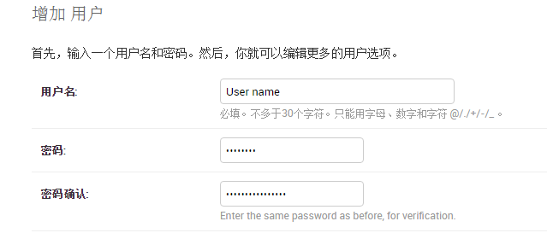

1. Manage server groups in GMs，Select the group to the right side of the selection bar.（Hold down Ctrl can choose more than one）

7.Timezone，Select the local time zone

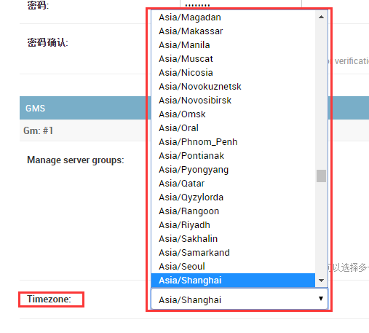

1. right click on "保存""seve"

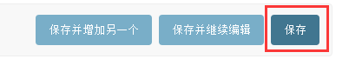

1. User setup is complete, you can see the groups Server before the announcement interface settings

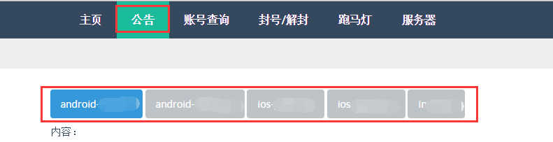

## Servers

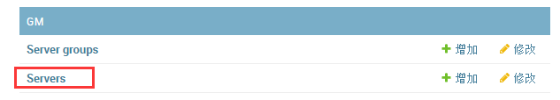

1. Right upper corner "add server" to add a server



1. Fill in server configuration

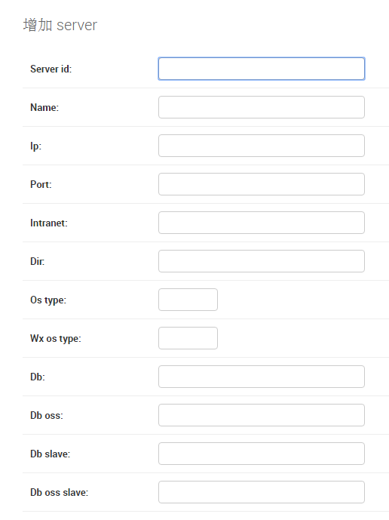

1. right click on "保存""seve"

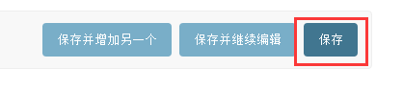

1. In the query, account title / marquee unsealing, see before the configuration for the server

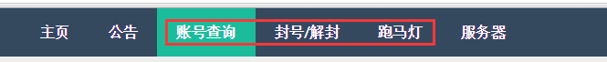

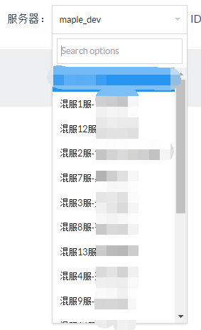 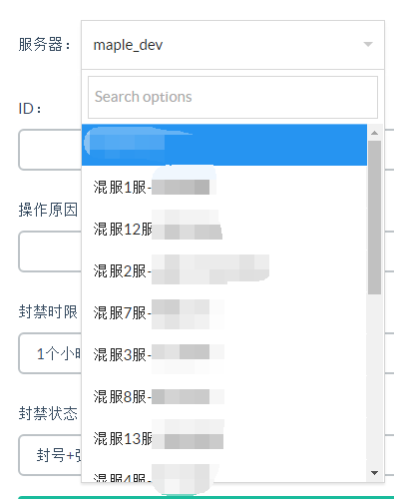

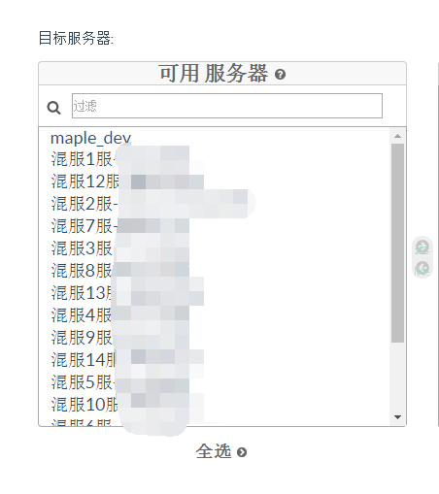

# GM

**一：公告=Notice**

1.choice server group



1. Write content

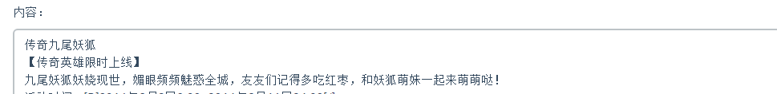

1. Send and modify



**二．帐号查询=Account inquiry**

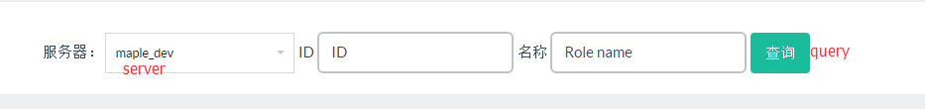

**三．封号/解封=Frozen account or Thaw account**

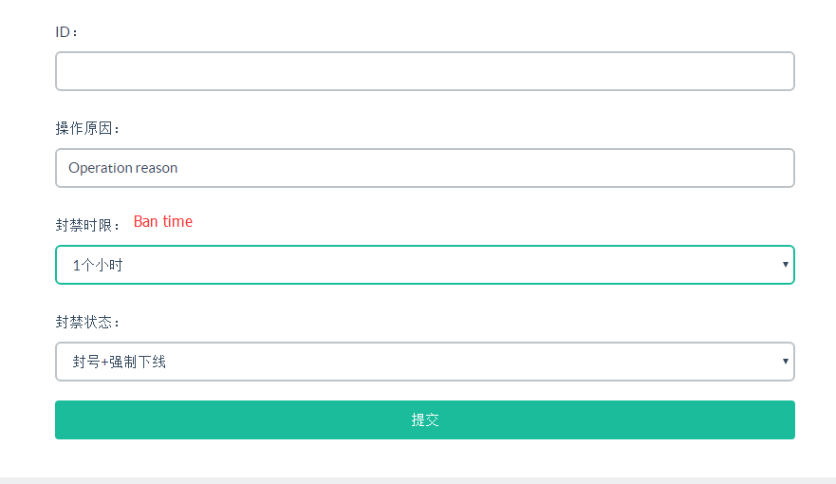

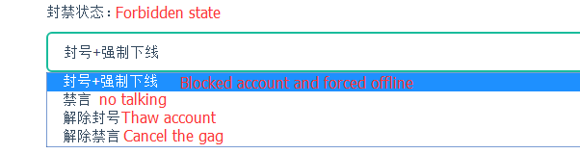

**四．跑马灯=Rolling notice**

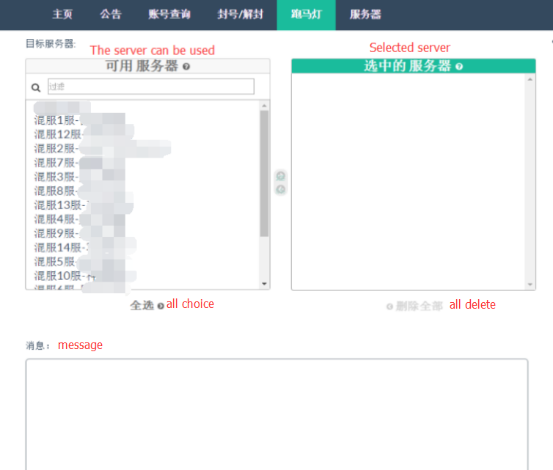

发送时间

